**SPM and Technical Summary Figures and Tables**

***Draft: 24-07-2020***

***Next Steps: Choose which Figures/Tables to include in SPM and which in TS***

**Figures/Tables submitted by: Ch1, Ch2, Ch4, Ch5, Ch8, Ch12, Ch13, Ch15, Ch17**

**Overview of figures nominated by chapters**

Section B

Figure B.1: Historical emissions

Figure B.2: Food system GHG emissions from agricultural sector and other sectors (energy, industry, product use, waste, other)

Figure B.3: Change in urban emissions, urban population and per capita emissions across time

Figure B.4: Global GHG emissions towards [2030? 2050?] resulting from implementation of NDCs

Figure B.5: Prevalence of legislation and strategy by region

Figure B.6: Sector and economy-wide policies and share of GHG covered

Figure B.7: Investment Needs

Figure B.8: Renewable share of annual power capacity expansion

Figure B.9: Variance of emissions in urban areas by size and region

Figure B.X: Direct vs indirect emissions

Figure B.X: Historical trends compared to scenarios

Figure B.X: Committed carbon

Figure B.X: Context and recent development in economy, emissions and climate/sustainability gaps

Section C

Figure C.1: Illustrative Pathways

Table C.1: Costs and Potentials

Figure C.2: Health and GHG emissions as outcomes of national food systems

Figure C.3: Demand-side: aggregated demand-side potential, individual carbon footprint reduction, and wellbeing implications

Figure C.4: Global Urban CO2 emissions – mapped to SSPs

Figure C.5: Global Urban Emissions (1950 – 2100)

Section D

Figure/Table D.1: Interlinkages between mitigation options and SDGs

Figure D.2: Just Transition(s)

Figure D.X: Shifting development pathways towards sustainability

Section E

Figure E.1: Mapping landscape of climate-development actions

Figure E.X: Governance (Title TBD)

Section not yet allocated

Figure ?.X: Per capita GHG emissions and development

Figure ?.X: Transition dynamics and determinants

Table X: Integrated Policy and Governance BOG Table

# **Section B**

## **Figure B.1**: Historical emissions

Section: B

Chapter: 2

Key Messages: Tied to B1 *Global GHG emissions have continued to rise since AR5 although the rate of growth has fallen since 20xx, especially in […] {2}*

Description (if provided by authors): On right and left there could be two columns added showing sectors’ emissions including indirect emissions.

|  |  |
| --- | --- |
| Figure 1: Trends in GHG emissions | Figure 2: GHG across regions |
| Figure 3: GHG in sectors |  |

## Figure B.2: Food system GHG emissions from agricultural sector and other sectors (energy, industry, product use, waste, other)

Section: B

Chapter: 12 [In Chapter as Figure 12.5]

Key Messages: Tied to B1 *Global GHG emissions have continued to rise since AR5 although the rate of growth has fallen since 20xx, especially in […] {2}*

Description (if provided by authors): Food system GHG emissions from the agriculture sector and from other sectors (Energy, Industry, Product use, Waste, Other*) (Crippa et al., submitted).

This figure could be developed in style and detail similar to other SPM figures on emission trends, with food system emissions by food supply chain stage and/or region (left), emissions by gas, indicating showing the percentages to total emissions.

*Food system - land use will be added in the SOD version

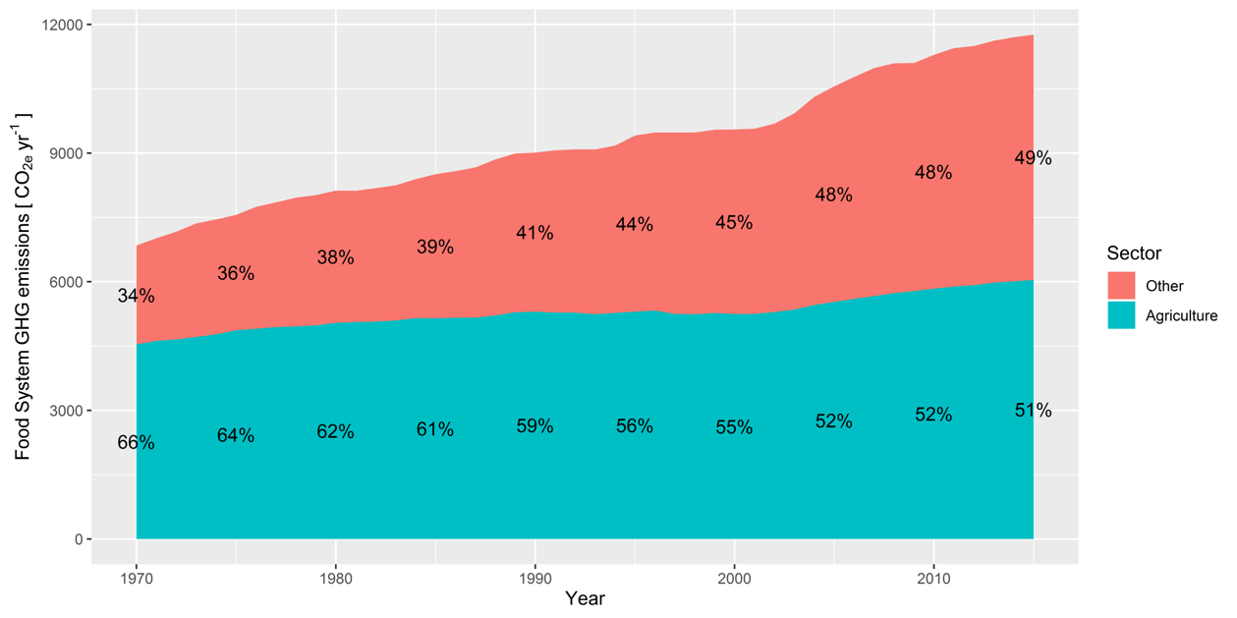

## Figure B.3: Change in urban emissions, urban population and per capita emissions across time

Chapter: 8

Key Messages: Maybe B1? *Global GHG emissions have continued to rise since AR5 although the rate of growth has fallen since 20xx, especially in […] {2}* Or B3

Description (if provided by authors)*:*

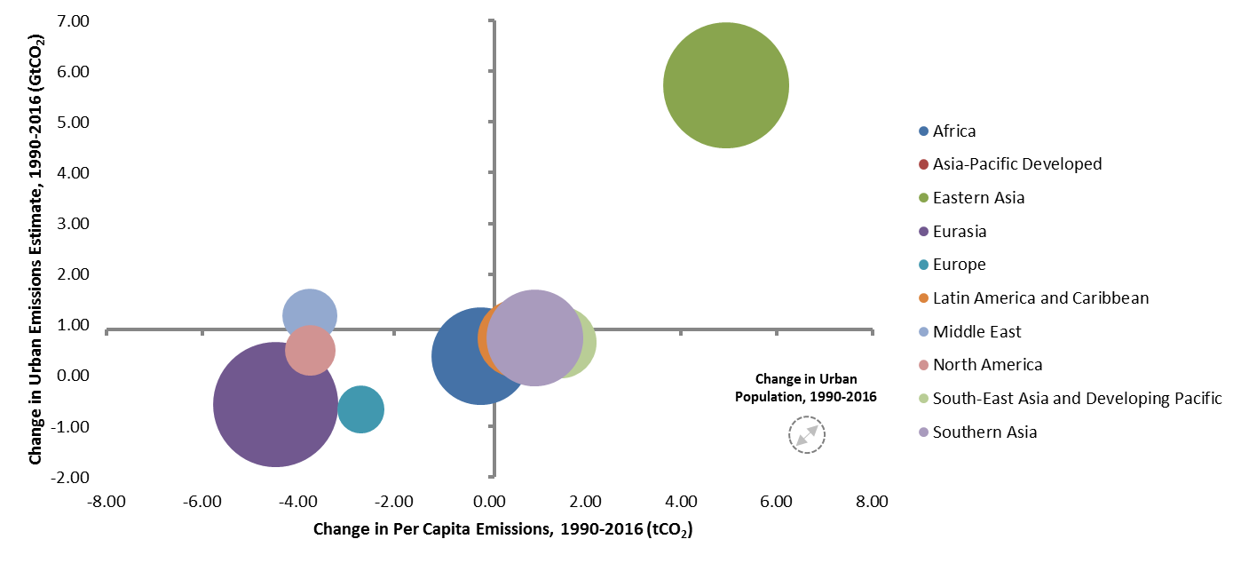

Note: Asia-Pacific Developed region data is not appearing due to overlap in middle area

## **Figure B.4**: Global GHG emissions towards [2030? 2050?] resulting from implementation of NDCs

Section: B

Chapter: 4 [From X-Chapter Box 1]

Key Messages: Tied to B2 *Current national commitments have brought projected aggregate global emissions below the levels associated with the implementation of current policies. Current commitments for 2030 are not in aggregate consistent with long-term pathways that will limit global warming to less than 2°C during the 21st century (xxx confidence). {4}*

Description (provided by authors)*:* Figure from the Cross-Chapter Box 1 between Ch3 and Ch4 comparison of projects of global GHG emissions that would emerge from the implementation of current policies and NDCs, illustrating emission gap.

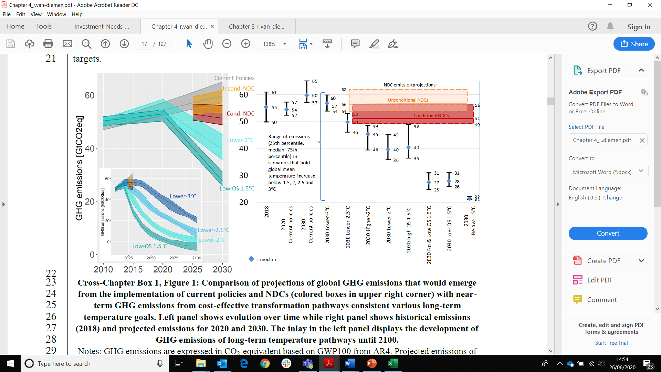

## **Figure B.5**: Prevalence of legislation and strategy by region

Section: B

Chapter: 13

Key Messages: Tied to B4 *Since AR5, many countries have developed cross-cutting climate policy frameworks and institutional arrangements. Gaps remain between the ambition of climate commitments and their effective implementation which can be attributed to the lack of sufficient policies and suitable institutions (xxx confidence). {13}*

Description (if provided by authors)*:* The figure shows a substantial increase over time in the share of greenhouse gases covered by national climate legislation and/or strategy between 2007 and 2017 (panel a), and an increase in the share of GHGs covered by national targets. It also illustrates the regions that account for the increases, as well as the relative impact over two periods: 2007-12 and 20012-17.

**Option 1:** Top: Shares of global GHG emissions under national climate change legislations and strategies; Bottom: Shares of global GHG emissions under executive or legislative national GHG emissions reduction targets – in 2007, 2012 and 2017. Note: AFR = Africa; ASIA = Asia; EUR = Europe (incl. Russia); NAM = North America; CSA = Central and South America; OCA = Oceania.

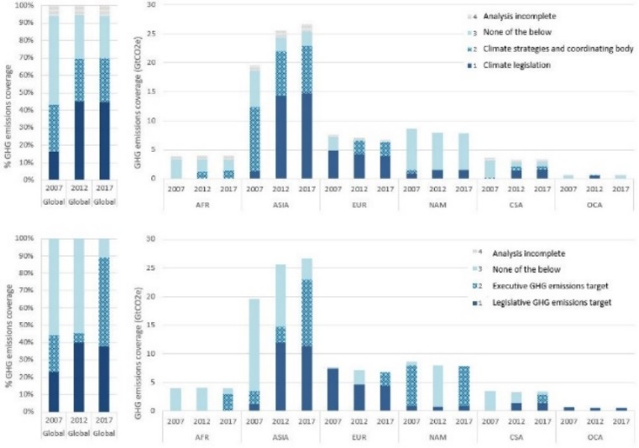

**Option 2**: Share of countries worldwide that had national climate change strategies or legislation and those that had national GHG emissions targets in force from 2006 to 2017, and the share of global GHG emissions covered by these strategies/legislation and targets.

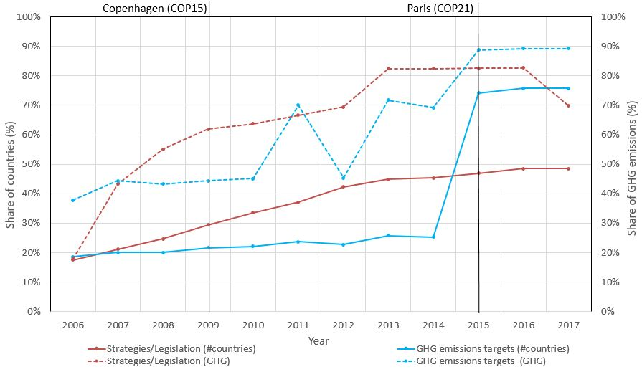

## Figure B.6: Sector and economy-wide policies and share of GHG covered

Section: B

Chapter: 13

Key Messages: Tied to B4 *Since AR5, many countries have developed cross-cutting climate policy frameworks and institutional arrangements. Gaps remain between the ambition of climate commitments and their effective implementation which can be attributed to the lack of sufficient policies and suitable institutions (xxx confidence). {13}*

Description (if provided by authors): The figure shows the growing prevalence over time of policies that result in mitigation (broadly organized by policy categories used in Ch 13, and shared with sector chapters) across a range of economic sectors (substantially corresponding to the sector chapters). The message is that there is a wide diversity of policy approaches being applied, and that prevalence is high across multiple sectors.

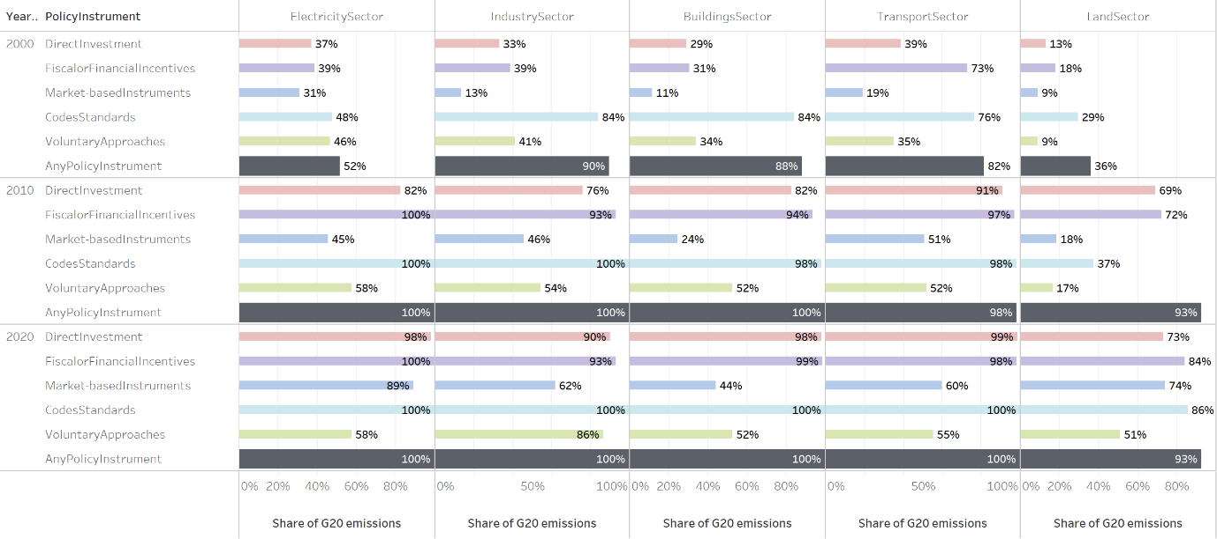

## Figure B.7: Investment Needs

Section: B

Chapter: 15

Key Messages: Tied to B7: *Climate financing needs have increased compared to AR5 levels driven by shorter period remaining until 2050/2030, relatively low mitigation investment activity in the past several years and rising levels of adaptation costs and linked to climate-related extreme events. Average annual mitigation investments required come in between [xx–yy] trillion USD for 2020–2030 with annual adaptation action expected to add between [xx–yy] trillion USD (xxx confidence). {15}*

Description (if provided by authors):

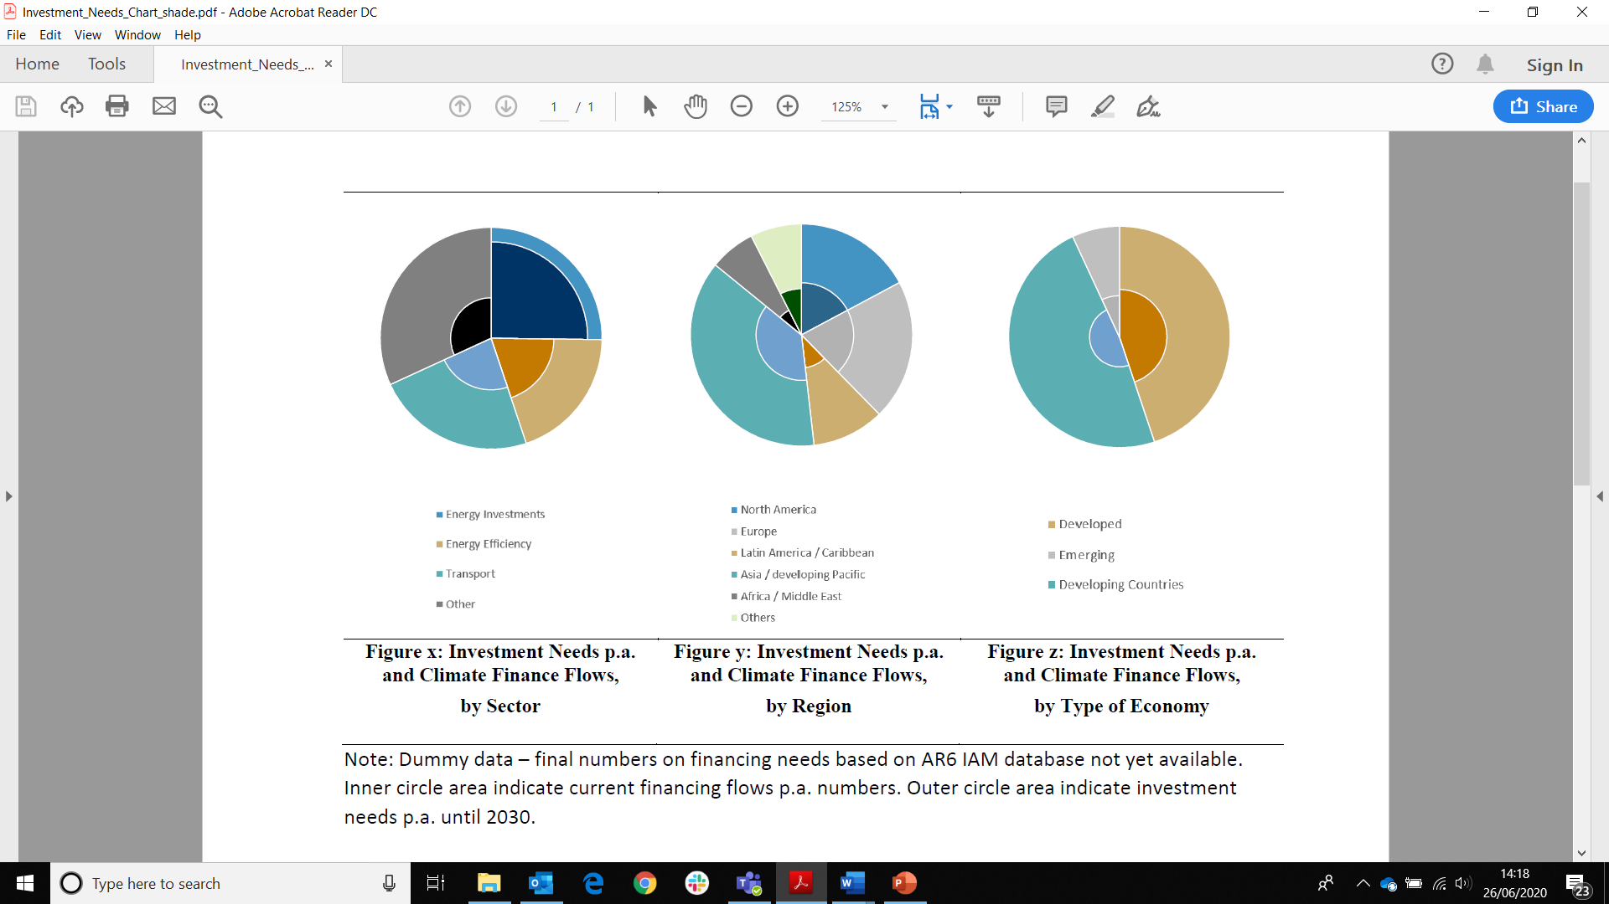

## Figure B.8: Renewable share of annual power capacity expansion

Section: B

Chapter: 12/6

Key Messages: Tied to B5.1 *From 2013 to 2017, generation from non-fossil electricity has increased by 23%. The vast majority of the growth has been solar PV and wind power, which have grown by 17% and 74%, albeit from low absolute levels. Growth in hydropower (7%), nuclear power (6%), and CCUS has been limited. The growth in non-fossil electricity generation is well below what would be needed to meet the Paris goals. (xxx confidence).*

Description (if provided by authors):

IRENA renewable capacity highlights, 31 March 2020. Bars could show contribution of the different electricity generation options



## Figure B.9: Variance of emissions in urban areas by size and region

Chapter: 8

Key Messages: Maybe B5? *In all sectors, there have been developments since AR5 which have limited GHG emissions below previously projected levels, or which have the potential to limit future emission reductions, reflecting the relevance of [technology, policies, behavior, …]*

Otherwise in C8: *The scale and pace of urbanization around the world, and especially the construction of new cities, risks carbon lock-in but also carries the potential to build low-carbon cities by designs that are conducive to both low-carbon lifestyles and technologies. There are large emissions reduction potentials associated with existing urban settlements and scope for avoided emissions from new demands in yet to be built urban settlements. {8}*

Description (if provided by authors)*:*

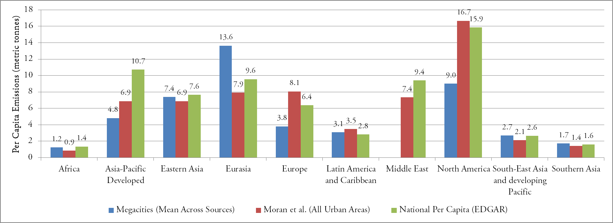

## Figure B.X: Direct vs indirect emissions

Chapter: 2

Key Messages:

Description (if provided by authors)*:* Jim mentioned this was the most used figure in the AR5 SPM. This figure is currently being developed by Ch2, but waiting on data that won’t be ready until September.

AR5 figure ([here](https://www.ipcc.ch/site/assets/uploads/2018/02/02_figure_SPM_2.png)):

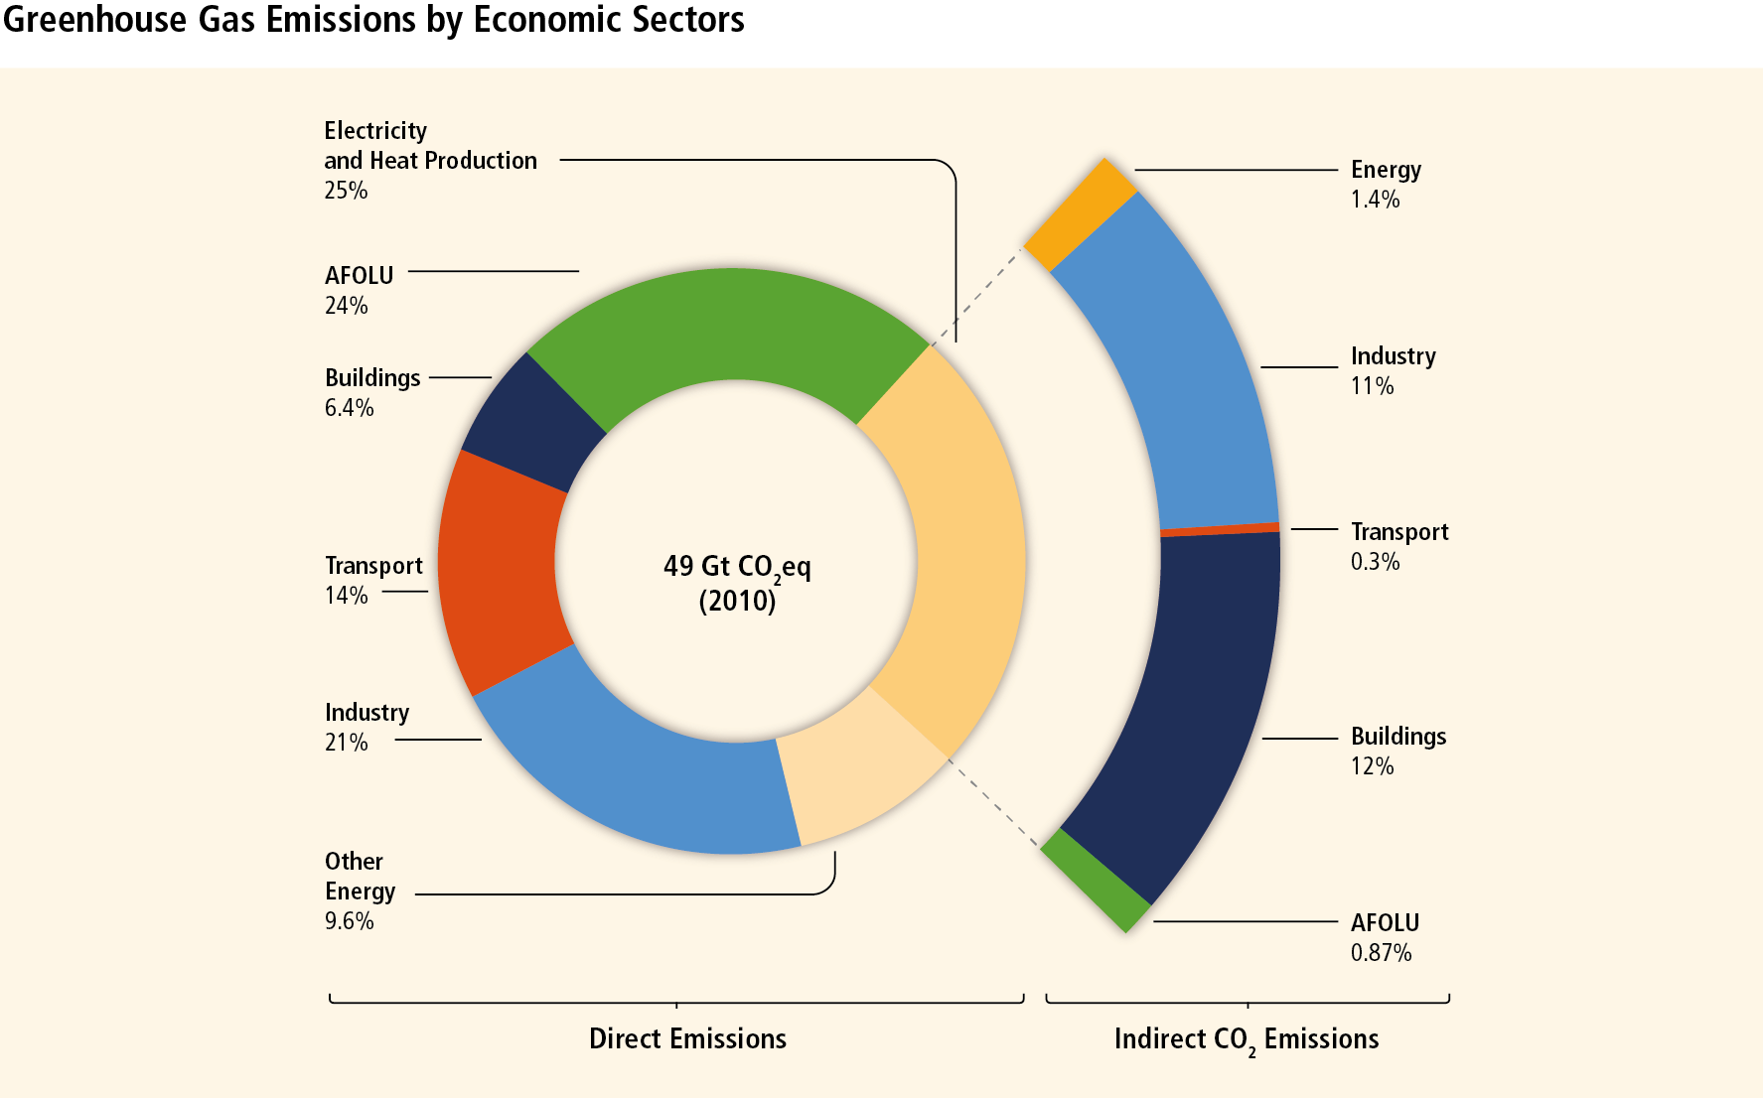

Figure SPM.2| Total anthropogenic GHG emissions (GtCO2eq/yr) by economic sectors. Inner circle shows direct GHG emission shares (in % of total anthropogenic GHG emissions) of five economic sectors in 2010. Pull-out shows how indirect CO2 emission shares (in % of total anthropogenic GHG emissions) from electricity and heat production are attributed to sectors of final energy use. ‘Other Energy’ refers to all GHG emission sources in the energy sector as defined in Annex II other than electricity and heat production [A.II.9.1]. The emissions data from Agriculture, Forestry and Other Land Use (AFOLU) includes land-based CO2 emissions from forest fires, peat fires and peat decay that approximate to net CO2 flux from the Forestry and Other Land Use (FOLU) sub-sector as described in Chapter 11 of this report. Emissions are converted into CO2-equivalents based on GWP1006 from the IPCC Second Assessment Report. Sector definitions are provided in Annex II.9. [Figure 1.3a, Figure TS.3 upper panel]

## Figure B.X: Historical trends compared to scenarios

Chapter: 2

Key Messages:

Description (if provided by authors)*:* Section B could have a figure that benchmarks historical trends against scenarios, describing how progress in most ambitious countries compares towards reduction rates in 1.5°C and 2°C scenarios.

Figure comparing emission reduction rates historically and in IAM scenarios. Note that we will not name countries, but just compare the ranges of evidence. Below you find a concept figure that we generated, but we will work on making something that is as intuitive as possible;

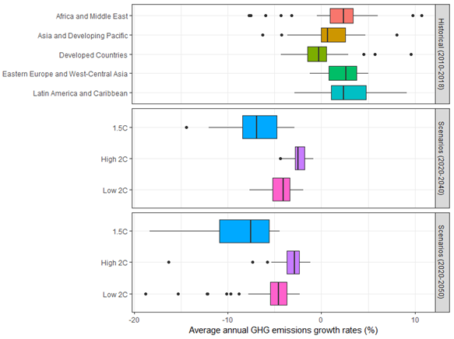

## Figure B.X: Committed carbon

Chapter: 2

Key Messages:

Description (if provided by authors)*:* Comparing committed emissions and the carbon budget. Published a version of this in the UN Emissions Gap report.

Currently in Ch2:

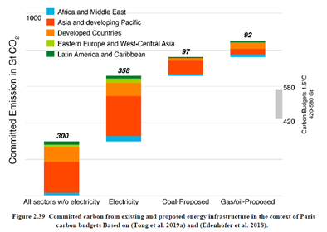

## Figure B.X: Context and recent development in economy, emissions and climate/sustainability gaps

Section: Not specifically allocated, but could fit in B (recent trends)

Chapter: 1 [Figure 1.2.3]

Description (if provided by authors): Chapter 1 Figure *1.2.3 Context and recent developments in economy, emissions, and climate / sustainability gaps*.

Figures 1.3a and 1.3b show the distribution of regional GHG emissions per capita and regional GHG emissions per GDP – power purchase parity of different country groupings. While the gap of per capita emissions between developed and developing countries has narrowed compared with 2004, the world remains unequal (described more fully in Chapter 2). GHG/GDP has been decreasing both in developed and developing countries.

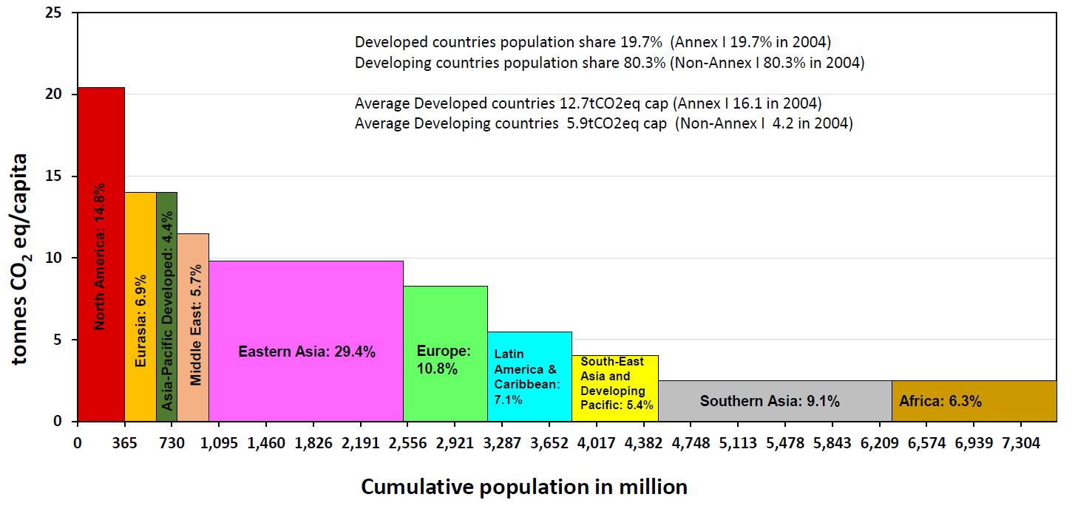**Figure 1.3 a Year 2018 distribution of regional per capita GHG emissions over the population of different country groupings. The percentage in bars indicate a region’s share in global GHG emissions. Annex I and non-Annex I data are taken from SPM 3a of the AR4.**

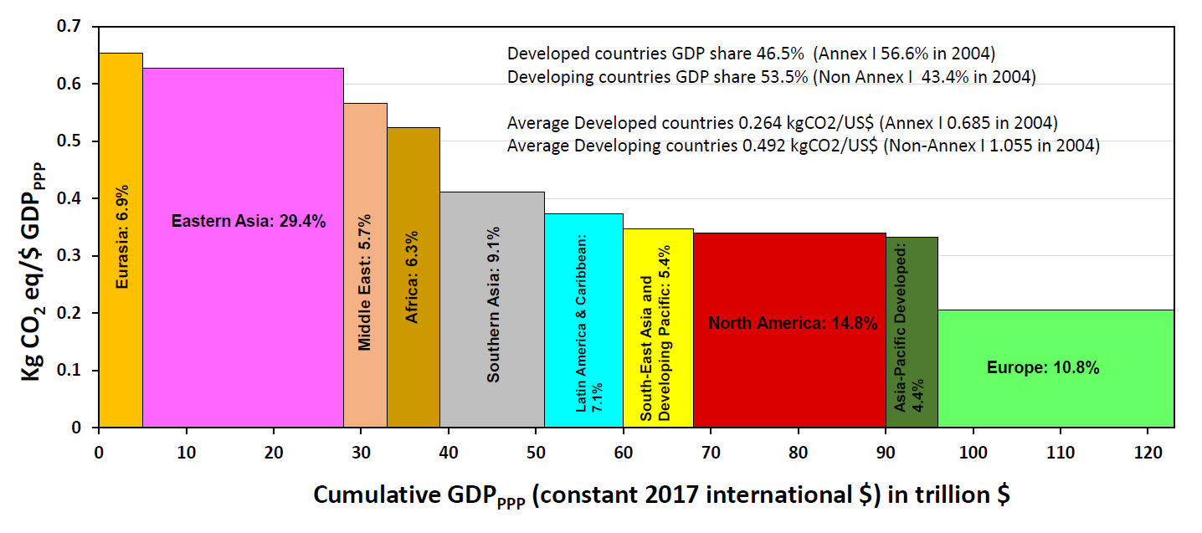

**Figure 1.3b Year 2018 distribution of regional GHG emissions over GDPppp pf different country groupings. The percentage in bars indicate a region’s share in global GHG emissions. Annex I and non-Annex I data has been taken from SPM 3.b of the AR4.**

# **Section C**

## Figure C.1: Illustrative Pathways

Section: C

Chapter: 3

Key Messages: Tied to C3 *Pathways describing rapid and extensive mitigation in the near term entail rapid decarbonization of the electric sector, increased service-demand efficiencies within the end-use sectors (transport, buildings, industry), and much greater deployment of low-carbon fuels (electricity, hydrogen, biofuels). Many of these pathways also entail negative emissions from the AFOLU sector and CDR. (xxx confidence) {3}*

Description (if provided by authors)*:* The illustrative pathways (IPs) describe a range of mitigation scenarios consistent with different temperature levels and alternative mitigation strategies. They illustrate trade-offs between different mitigation and policy choices. [CH LEAD: 3]

*Also provided by Ch1*: Ch1 view is that the Technical Summary should have a representation of WGIII Illustrative Pathways. Given that no IPs data is available as of the date of submission of candidate exhibits, we are putting forward a sketch of what this figure will look like once we have such data. We would also like to stress that an IPs figure does not necessarily need to come from Chapter 1, as IPs are part of Chapter 3 content. However, we would like to indicate by Figure 1.2 below that we believe IPs should be represented in the TS.

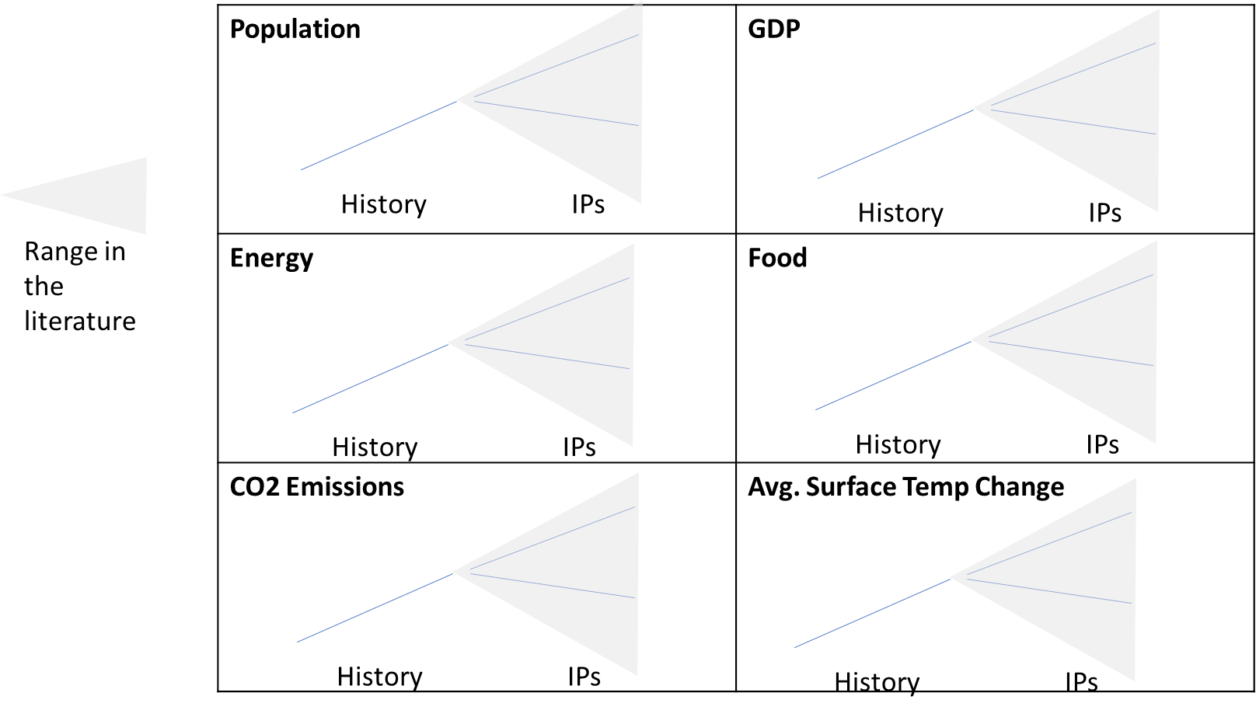

## Table C.1: Costs and Potentials

Section: C

Chapter: 12

Key Messages: Tied to C4 *[Mitigation Costs and Potentials]*

Description (if provided by authors)*:* Suggested table compiling Costs and Potentials from sectors and systems

## Figure C.2: Health and GHG emissions as outcomes of national food systems

Section: C

Chapter: 12

Key Messages: Tied to C5*: Studies show that a shift to diets with higher share of plant protein could lead to substantial reduction of GHG emissions and nutrient losses, while at the same time**providing health benefits and reducing mortality from diet-related non-communicable diseases (robust evidence, high agreement).*

Description (if provided by authors)*:*

Health and GHG emissions as outcomes of national food systems.

* The x-axis shows the cost for food (whole sale price) per capita (Springmann et al., in review);
* The y-axis shows the ratio of GHG emissions from energy to GHG emissions from energy and land (Crippa et al., submitted).
* The size of the points shows the total food system GHG emissions in a country per capita and year (Crippa et al., submitted).
* The sizes of the area in the circles in red, yellow, and blue indicate the relative share of deaths attributed to Child and maternal malnutrition (red), Dietary risks (yellow), or High body-mass index (blue) (IHME 2018; GBD 2017 Diet Collaborators et al. 2019).

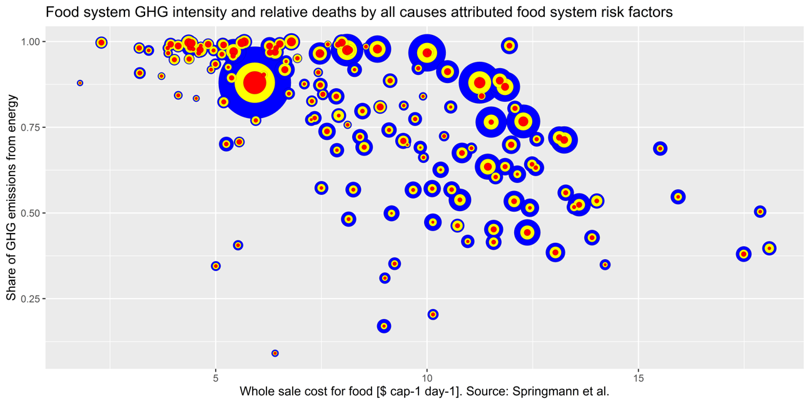

## Figure C.3: Demand-side: aggregated demand-side potential, individual carbon footprint reduction, and wellbeing implications

Section: C

Chapter: 5

Key Messages: Tied to C5*: Demand-side mitigation measures increase the likelihood of equitable service provision and offer the potential to decouple GHG emissions and GDP growth. Policies encouraging demand-side measures complement supply-side interventions by limiting the need for new energy supplies, the reliance on negative emissions technologies and associated demand for land. (xxx confidence) {5}*

Description (if provided by authors)*:*

Ch5 suggest a SPM figure that would be done in coordination with chapters 6, 7, 8, 9, 10, and 11, building on existing communication channels and cooperation.

SPM Figure Demand-side aggregated demand-side potential, individual carbon footprint reduction, and wellbeing implications {5,6,7,8,9,10,11}.

Panel A: Aggregate potential (derived from LED, but modified), possibly organized along A-S-I

Panel B: Carbon footprint reduction (derived from Ivanova et al 2020)

Panel C: Wellbeing implications (derived from cross-sector exercise on A-S-I and wellbeing). We may also indicate where behavioral change, structural change, and change in social norms is required, possibly as panel.

## Figure C.4: Global Urban CO2 emissions – mapped to SSPs

Chapter: 8

Key Messages: Maybe C8? *The scale and pace of urbanization around the world, and especially the construction of new cities, risks carbon lock-in but also carries the potential to build low-carbon cities by designs that are conducive to both low-carbon lifestyles and technologies. There are large emissions reduction potentials associated with existing urban settlements and scope for avoided emissions from new demands in yet to be built urban settlements.*

Description (if provided by authors)*:*

Notes:

* Use Liang and O’Neill urban share % by country by 5 SSPs
* Use national population by country by SSPs (IIASA DB)
* Use historical urban pop from UNDESA (1950-2019)
* Use per capita urban CO2 by country from Moran et al.

TBD

* Vary per capita over time by SSP (current per cap CO2 is vintage 2015 and fixed)
* Use nation-specific per cap CO2 from literature in some national cases

|  |  |
| --- | --- |
|  |  |
|  |  |
|  |  |

## Figure C.5: Global Urban Emissions (1950 – 2100)

Chapter: 8

Key Messages: Maybe C8? *The scale and pace of urbanization around the world, and especially the construction of new cities, risks carbon lock-in but also carries the potential to build low-carbon cities by designs that are conducive to both low-carbon lifestyles and technologies. There are large emissions reduction potentials associated with existing urban settlements and scope for avoided emissions from new demands in yet to be built urban settlements.*

Description (if provided by authors)*:*

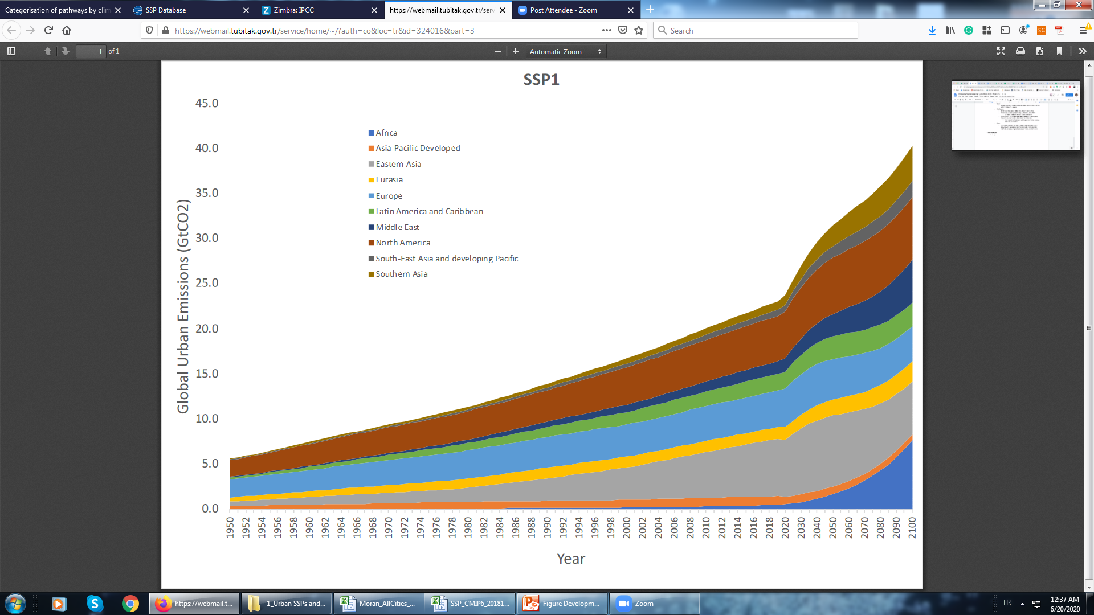

# Section D

## Figure/Table D.1: Interlinkages between mitigation options and SDGs

Section: D

Key Messages: Tied to D3 *Mitigation options may involve co-benefits and trade-offs with Sustainable Development Goals (SDGs). These are context specific, depend on the timing of mitigation actions, policy design and effectiveness. Many adverse impacts can be compensated or avoided with complementary policies and investments (xxx confidence). {7, 11}*

Description*:* Empirical assessment showing mitigation options and interactions with SDGs.

The following image was provided by Chapter 12

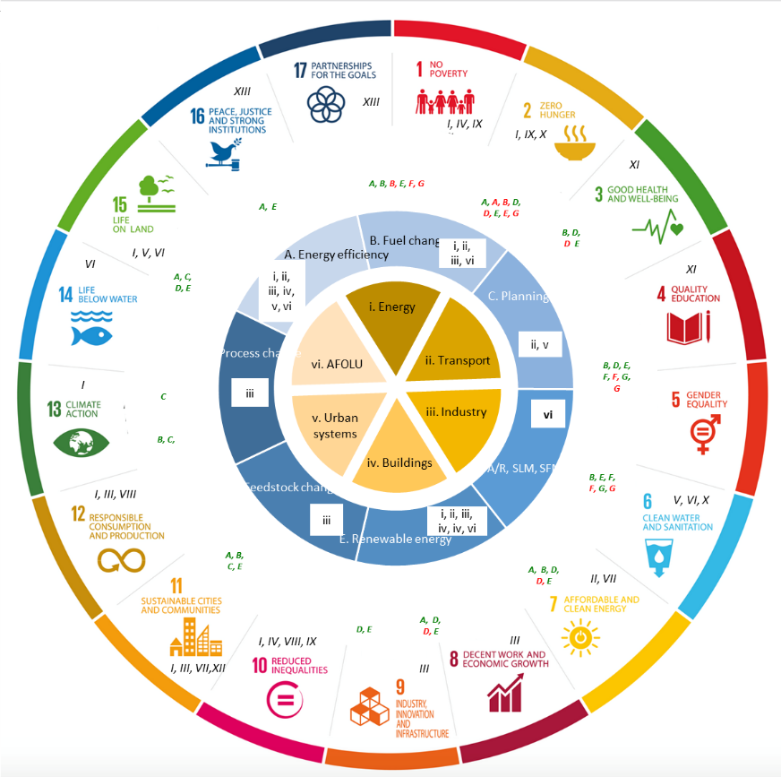

**Figure 1: Co-benefits and adverse side effects of mitigation actions with links to the SDGs. The inner circle represents the sectors in which mitigation occurs (i to iv). The second ring shows different generic types of mitigation actions (A to G), with the small roman numerals showing which sectors they are applicable to. The third ring indicates different types of climate related co-benefits (green letters) and adverse side effects (red letters) that can be achieved through mitigation action. Here I relates to climate resilience, II-IV economic co-impacts, V-VII environmental, VIII-XII social, and XIII political and institutional, with the classification adapted from (Mayrhofer and Gupta 2016). These are again linked to the mitigation actions. The final ring maps co-benefits and adverse side-effects to the SDGs.**

Note: in block D, A/R = afforestation/deforestation, SLM = sustainable land management, SFM = sustainable forest management

## Figure D.2: Just Transition(s)

Section: D

Chapter: 4 [Figure 4.10]

Key Messages: D.4: *Transitions pathways depend on resource endowments, equity considerations, existing development patterns, the speed of action, and context-specific issues that may enable or act as a barrier to transitions {17}. The distribution of economic implications of mitigation may imply large employment and economic structural changes, stranded assets and raises multiple types of distributional concerns (xxx confidence). Perceptions of equity enable broader consensus for the transformational change implied by deeper mitigation efforts. {4}*

Description (if provided by the authors)*:* Revised version of Figure 4.10: Just Transition Commissions and Policies around the world, 2020 (year will be adjusted in figure)

Detailed design of mitigation policies is critical for more equitable distributional impacts. The equity consequences of mitigation activities depend on how costs and benefits are initially incurred and how they are shared as per social contracts, national policy, and international agreements. Relation between the effectiveness of cooperative action and the perception of fairness of such arrangements, in that this enables broader consensus for the transformational change implied by deeper mitigation efforts. Hence, equity is an ethical imperative, but it is also instrumentally important.

## Figure D.X: Shifting development pathways towards sustainability

Section: Not specified by authors, but could be D or E

Chapter: 4 [Figure 4.7]

Key Messages: Maybe D1 or E1?

Shifting development pathways toward increased sustainability (SDPS) opens up wider and more effective options for meeting mitigation and multiple development objectives simultaneously. Such a shift draws on a broad set of instruments and measures to accelerate progress, not only mitigation but also on the broader SDG agenda.Focusing on shifting development pathways toward increased sustainability influences the ultimate drivers that determine the capacity of a society for both adaptation and mitigation. Policies in several areas can shift development pathways, directly advancing development goals, increasing resources to meet goals, and reducing emissions. Enabling conditions in a wide range of areas need to come together in a co-evolutionary process to shift development pathways that could scale and accelerate transformative mitigation consistent with 2°C-1.5°C pathways and broader sustainable development goals. Making development pathways more sustainable can increase capacity for both greater adaptation and mitigation. Adaptation and mitigation benefits can be produced together, with specific examples of synergies (while not ignoring trade-offs) in relation to agriculture, blue carbon and ecosystem services

Description (if provided by authors)*:* Figure 4.7. On shifting development pathways towards sustainability

# Section E

## Figure E.1: Mapping landscape of climate-development actions

Section: E

Chapter: 13

Key Messages: E2: *Policies (along with other enabling conditions) can shift development pathways, directly advance development goals, increase resources to meet goals, reduce emissions, and reduce negative distributional impacts. Effective institutions support the acceleration of climate mitigation efforts {13}*

Also D.1: *The way countries develop determines the scope for meeting mitigation and multiple development objectives simultaneously (medium/high evidence, medium agreement). Approaches targeting more sustainable outcomes open up a wider range of options and enables more effective implementation (xxx confidence). {4}*

Description (if provided by authors)*:* The diagram provides a conceptual mapping of a space to understand the wide range of policies that result in mitigation, and how they may be differently motivated in different countries. This space is mapped by two axes: mitigation in the context of sustainable development, and approaches to acceleration. The mapping also shows how governance needs and the potential for co-benefits increase across different dimensions. The illustrative policies placed with the space help convey the diverse approaches to mitigation in the context of sustainable development, that different countries may choose different approaches based on their context, and that there are pathways to enabling transformation.

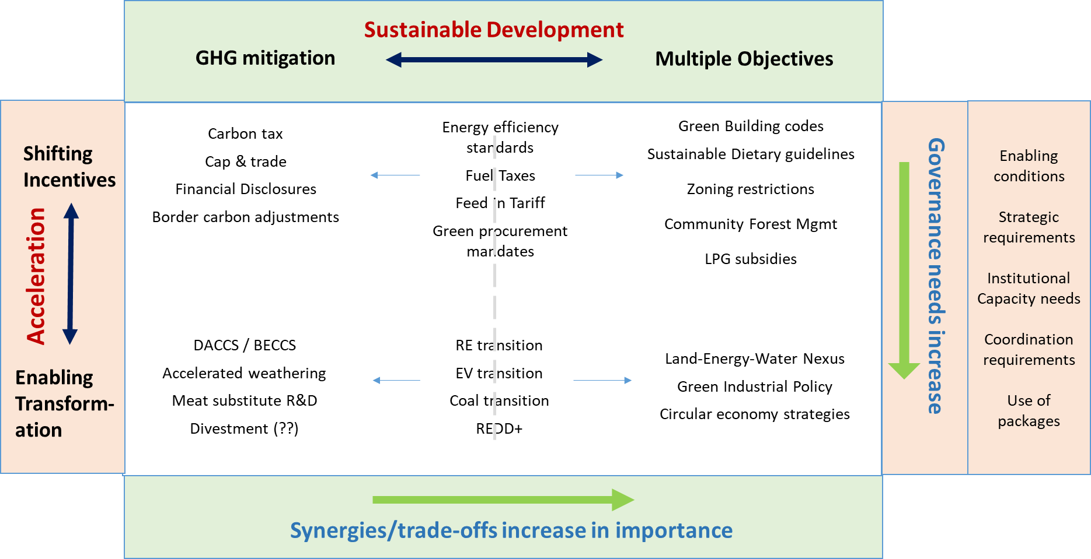

## Figure E.X: Governance (Title TBD)

Section: Not specified by authors, but could be E

Chapter: 8

Key Messages:

Description*:* Notes: Work in progress – requesting graphic design assistance. Would be helpful to know how governance will be discussed in the SOD, if it will continue to be sequestered into its own section (as with the FOD) or if it will be integrated throughout. If the latter, the conceptualization of governance as a way to reveal policy pathways/opportunities for urban mitigation might be a better approach.

Potential titles:

**Figure 8.x** Governance[or Policy Implementation Pathways?] for Urban Climate Change Mitigation  
**Figure 8.x** Beyond Multilevel Governance: Polycentric Scalar [or Multi-scalar?] and Multi-player Climate Change Governance  
**Figure 8.x** Governance Systems and Urban Climate Change Mitigation

Caption: *In progress* Since AR6, conceptualizations of urban climate change governance have become increasingly complex [throughout the literature]. Explorations of specific case studies have revealed that policy influence and decision-making runs top-down, bottom-up, over and through all levels or geopolitical scales of governance (e.g. regional, district, state, national, global, etc.). These dynamics reveal multiple policy pathways for urban mitigation implementation. Due to its focus on urban mitigation, this figure does not show additional dynamics between other scales of governance. [Will add more]

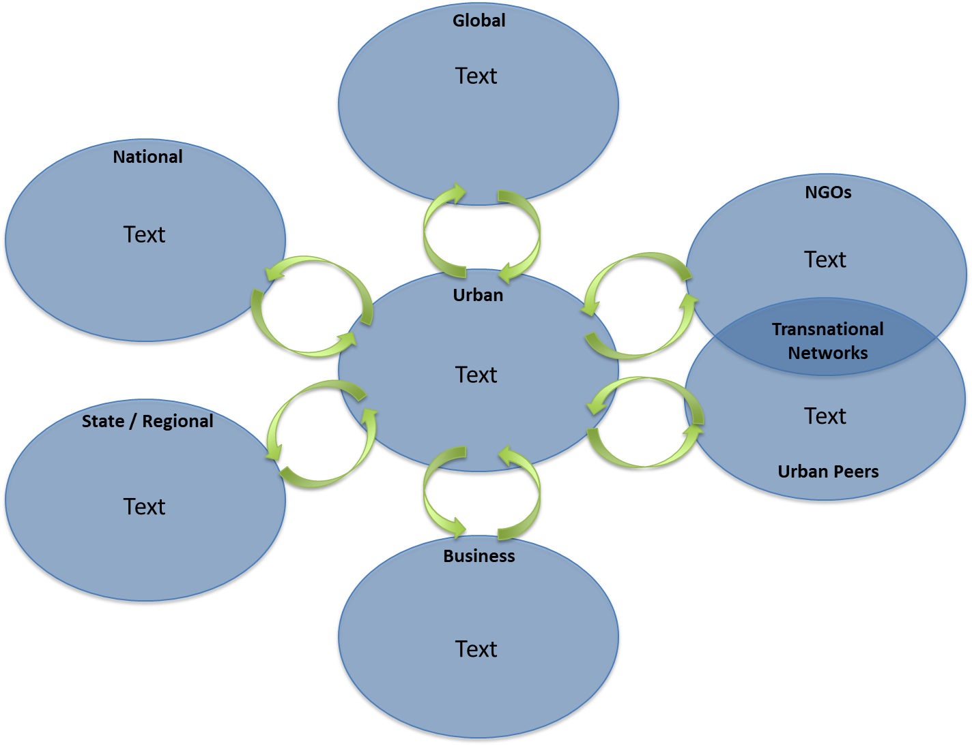

# Section not yet allocated

## Figure ?.X: Per capita GHG emissions and development

Section: Not specified by authors – could fit between B and C, or even in D

Chapter: 1 [Figure 1.5]

Description (if provided by authors)*:* Chapter 1 Figure 1.5, part of Chapter 1 section *1.4.2 Climate Mitigation, Equity and Sustainable Development Goals (SDGS)*.

Figure 1.5 presents three graphs a), b) and c). Graph a) shows there is a very wide range of national per capita GHG emissions and income levels even for countries with similar levels of development or industrialisation. Some countries have very low per capita GHG emissions and income even by historical standards, meanwhile others have very high per capita emissions and income. The important thing is that all countries need to move on a pathway towards sustainability. Importantly, sustainability takes more than low GHG emissions, but also involves some level of industrialisation to support development aspirations and fulfilling the SDGs.

With the industrial revolution and industrialisation in recent times, has come increased income for some countries and people. With regards to income levels, up until GDP per capita income levels in the range $10,000-20,000 there is clear relationship between GDP increase and almost every more direct indicator of welfare. However, at higher incomes the relationship becomes progressively less clear. When it comes to LDCs, other developing economies, emerging industrial economies and industrialised economies, GDP per capita is an important metric but not the only metric defining these categories. Levels of agriculture and manufacturing are also defining characteristics, and in the case of LDCs so are levels of economic vulnerability (including the share of population in low elevated coastal zones) and human assets. As such, these development and industrialisation categories capture important characteristics of countries, their economies and possible pathways towards sustainability.

Graph b) plots regional per capita emissions by level of development and industrialisation. Even though the horizontal axis uses life expectancy at birth as a proxy of development, the relationship between per capita and development (including industrialisation) remains much the same, including a wide range of per capita emissions even for similar levels of development and industrialisation.

Graph C) schematically plots a development pathway towards sustainability, a transition pathway towards sustainability and two intermediate pathways. For high per capita GHG emissions jurisdictions, a transition pathway towards sustainability involves rapid per capita GHG emissions reductions. For low emissions and development jurisdictions, a development pathway towards sustainability could take the form of an arc that allows for some increased per capita emissions while staying below the historic global per capita emissions curve and well below the 2°C emissions curve over time. However, it is important to note, low emissions alone are not adequate to fulfil the SDGs.

**Per Capita GHG Emissions and Development Diagram**

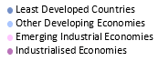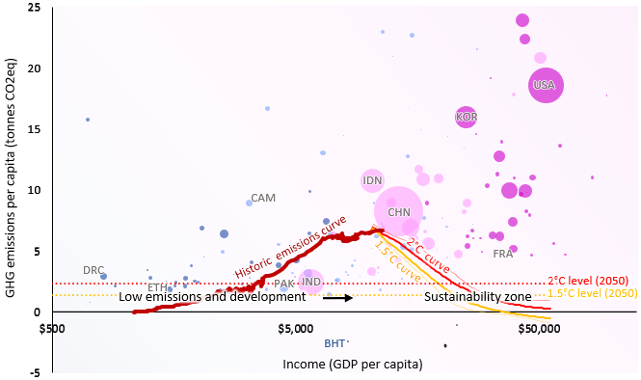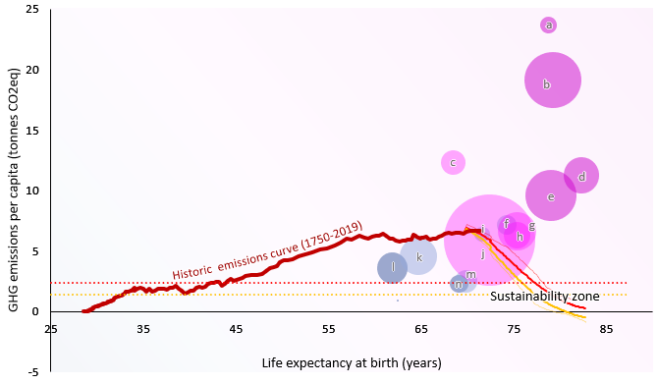

1. Regional per capita emissions and global per capita emissions curves

**Figure 1.5: a)** National per capita GHG emissions and income for the year 2015 with bubble sizes representing total GHG emissions. Overlaying national data are historic global average per capita GHG emissions relative to per capita income from the start of the industrial revolution to present (1750-2014), as well as projected 1.5°C and 2°C per capita emissions curves (2010-2100) assuming medium population projections and global economic growth fulfils the OECD’s long term projections. Dotted lines show the levels of per capita emissions needed to limit global warming to 1.5°C and 2°C in the year 2050. With each additional year, the dotted lines (i.e. levels) go down. The low emissions zone extends down from well below 2°C meanwhile the sustainability zone involves limiting global warming to well below 2°C and a level of industrialisation to support fulfilment of development aspirations and SDGs. **b)** Regional per capita emissions relative to life expectancy at birth with bubble sizes representing total regional emissions for: (a) Industrial economies in the Middle East; (b) Industrial economies in North America; (c) Emerging industrial economies in Africa and Middle East; (d) Industrialised economies in Asia and Pacific; (e) Industrialised economies in Europe and Eurasia; (f) Other developing economies in Latin America and Caribbean; (g) Emerging industrial economies in Latin America and Caribbean; (h) Emerging industrial economies in Europe and Eurasia; (i) Emerging industrial economies in Asia and Pacific; (j) Other developing countries in Europe and Eurasia; (k) Other developing economies in Africa and Middle East; (l) Least Developed Countries in Africa and Middle East; (m) Other developing economies in Asia and Pacific; and, (n) Least Developed Countries in Asia and Pacific. Historic per capita emissions are plotted relative to life expectancy at birth, meanwhile 1.5°C and 2°C curves are plotted assuming medium population and life expectancy projections. **C)** Is a schematic diagram illustrating GHG emissions per capita on the vertical axis and wellbeing on the horizontal axis and shows different pathways towards sustainability. This includes development pathways where development and some level of industrialisation is required to fulfil the SDGs, meanwhile transition pathways towards sustainability involve rapid decarbonisation and drops in per capita GHG emissions.

1. National per capita emissions and global per capita emissions curves

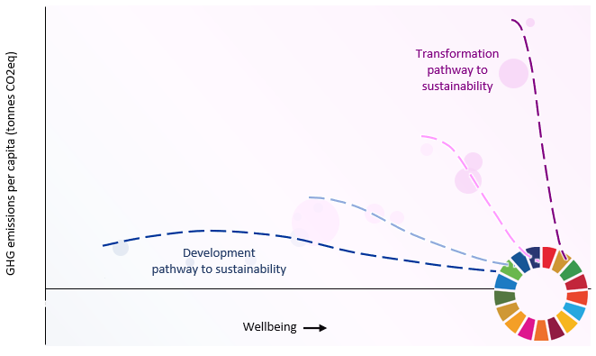

1. Schematic pathways towards sustainability

## Figure ?.X: Transition dynamics and determinants

Section: Not specified by authors, but could fit in D or E

Chapter: 1 [Figure 1.8]

Description (if provided by authors)*:*

*Figure 1.8 Transition dynamics and determinants*, located in Chapter 1 section *1.6.4 Frameworks for transition and transformation.*

Transitions typically involve highly non-linear changes, with a long period of emergence followed by rapid growth of new technologies, ideas and behavior (including regarding policy). There are multiple interacting societal / governance levels involved in such transitions, with different dominant actors and decision-making processes. Incumbent interests and mindsets associated with existing mid-level structures may impede transitions; whilst changes in market, pricing and regulatory structures driven mainly by governments (A), and in technological systems driven by new businesses and communities (B), can accelerate transitions. Transitions involve challenges and opportunities, including distributional consequences.

## Table X: Integrated Policy and Governance BOG Table

NOTE: Chapter proposes this to be considered for the TS, not the SPM

Chapter: 13

Key Messages: *Maybe tied to C12? Emphasizing interactions between sectors to achieve sustained and deep net reduction*

Description (if provided by authors)*:*

This table draws on sectoral case studies across Chapters 5-12**. It aims to highlight real world implementation complexity of policy mixes given governance conditions. It underscores the diversity of sectoral actions that contribute to mitigation across geographies.

**The sectoral chapters feature detailed case study boxes whereas Chapter 13 will include this integrative table.

